Chapter 14, Problem 23.

The Bode magnitude plot of H(ω) is shown in Fig. 14.75. Find H(ω).

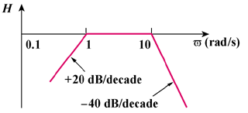
(db)

0
ω (rad/s)

Figure 14.75
For Prob. 14.23.

